**Chapter-7**

System Design

**7.1 Database  
7.2 Normalization  
7.3 Database Table Structure  
7.4 Output Screen**

**7. System Design**

**7.1 Database**

After carefully understanding the requirements the entire data storage requirements are divided into tables. The tables are normalized to avoid any anomalies during the course of data entry.

**7.2 Normalization**

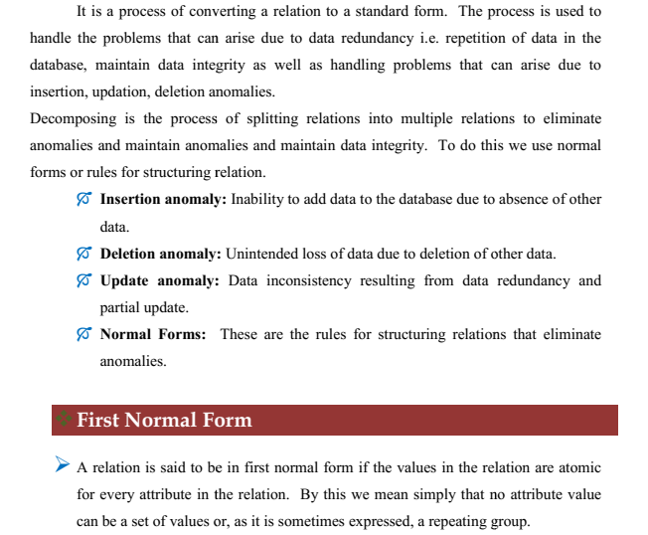

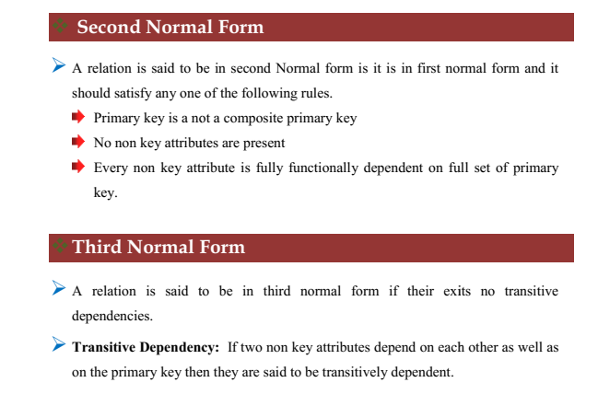

**7.3 Database Table Structure**

**Admin Table**

|  |
| --- |

|  |  |  |  |
| --- | --- | --- | --- |
| Name | Type | Collation | Attributes |
| |  | | --- | | **slPrimary** | | |  | | --- | | int(2) | |  |  |
| |  |  | | --- | --- | | **powerIndex** |  | | enum('super', 'admin', 'editor') | |  |  | | --- | --- | | *utf8_unicode_ci* |  | |  |
| |  |  | | --- | --- | | **usernameIndex** |  | | varchar(25) | |  |  | | --- | --- | | *utf8_unicode_ci* |  | |  |
| |  |  |  | | --- | --- | --- | | **passIndex** |  |  | | varchar(250) | *utf8_unicode_ci* |  |
| |  |  | | --- | --- | | **emailIndex** |  | | varchar(63) | *utf8_unicode_ci* |  |
| |  |  | | --- | --- | | **phoneIndex** |  | | varchar(11) | |  |  | | --- | --- | | *utf8_unicode_ci* |  | |  |
| |  |  | | --- | --- | | **StatusIndex** |  | | enum('active', 'inactive') | |  |  | | --- | --- | | *utf8_unicode_ci* |  | |  |

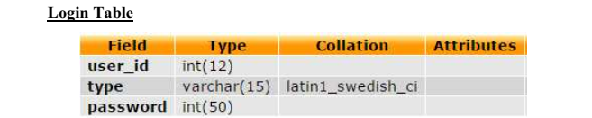

**Teacher Table**

|  |  |  |  |
| --- | --- | --- | --- |
| Name | Type | Collation | Attributes |
| |  |  | | --- | --- | | |  | | --- | | **slPrimary** | | | |  | | --- | | int(2) | |  |  |
| username | varchar(25) | utf8_unicode_ci |  |
| pass | varchar(250) | utf8_unicode_ci |  |
| email | varchar(63) | utf8_unicode_ci |  |
| phone | varchar(11) | utf8_unicode_ci |  |
| fullname | varchar(30) | utf8_unicode_ci |  |
| photo_name | varchar(250) | utf8_unicode_ci |  |
| subject | varchar(30) | utf8_unicode_ci |  |
| status | enum('active', 'inactive') | utf8_unicode_ci |  |
| dob | date |  |  |
| joining_date | date |  |  |
| qualification | varchar(30) | utf8_unicode_ci |  |
| corrent_salary | decimal(10,2) |  |  |

**Employee Table**

|  |  |  |  |
| --- | --- | --- | --- |
| Name | Type | Collation | Attributes |
| |  |  | | --- | --- | | |  | | --- | | **slPrimary** | | | |  | | --- | | int(3) | |  |  |
| category | enum('committee', 'staff') | utf8_unicode_ci |  |
| photo_name | varchar(150) | utf8_unicode_ci |  |
| username | varchar(50) | utf8_unicode_ci |  |
| pass | varchar(50) | utf8_unicode_ci |  |
| fullname | varchar(30) | utf8_unicode_ci |  |
| designation | varchar(80) | utf8_unicode_ci |  |
| email | varchar(63) | utf8_unicode_ci |  |
| phone | varchar(11) | utf8_unicode_ci |  |
| basicsalary | decimal(10,2) |  |  |
| status | enum('active', 'inactive') | utf8_unicode_ci |  |

**Student Table**

|  |  |  |  |
| --- | --- | --- | --- |
| Name | Type | Collation | Attributes |
| |  |  | | --- | --- | | |  | | --- | | **slPrimary** | | | |  | | --- | | int(11) | |  |  |
| year | varchar(4) | utf8_unicode_ci |  |
| myclass | int(2) |  |  |
| status | enum('active', 'tc') | utf8_unicode_ci |  |
| studentId | int(10) |  |  |
| classroll | int(3) |  |  |

**Subject Table**

|  |  |  |  |
| --- | --- | --- | --- |
| Name | Type | Collation | Attributes |
| sl | int(11) |  |  |
| studentId | int(15) |  |  |
| myclass | int(2) |  |  |
| year | int(11) |  |  |
| subjectcode | int(3) |  |  |
| category | enum('main', 'optional') | latin1_swedish_ci |  |

**Mark Table**

|  |  |  |  |
| --- | --- | --- | --- |
| Name | Type | Collation | Attributes |
| sl | int(11) |  |  |
| myclass | int(2) |  |  |
| year | varchar(4) | latin1_swedish_ci |  |
| term | enum('FirstTerm', 'Midterm', 'Annual') | latin1_swedish_ci |  |
| studentId | int(15) |  |  |
| subjectcode | int(3) |  |  |
| mark | decimal(4,2) |  |  |
| remark | decimal(1,0) |  |  |
| datetime | datetime |  |  |
| status | enum('published', 'pending') | utf8_unicode_ci |  |
| category | enum('main', 'optional') | utf8_unicode_ci |  |

**7.4 OUTPUT SCREENS**

**SMS Home Page**

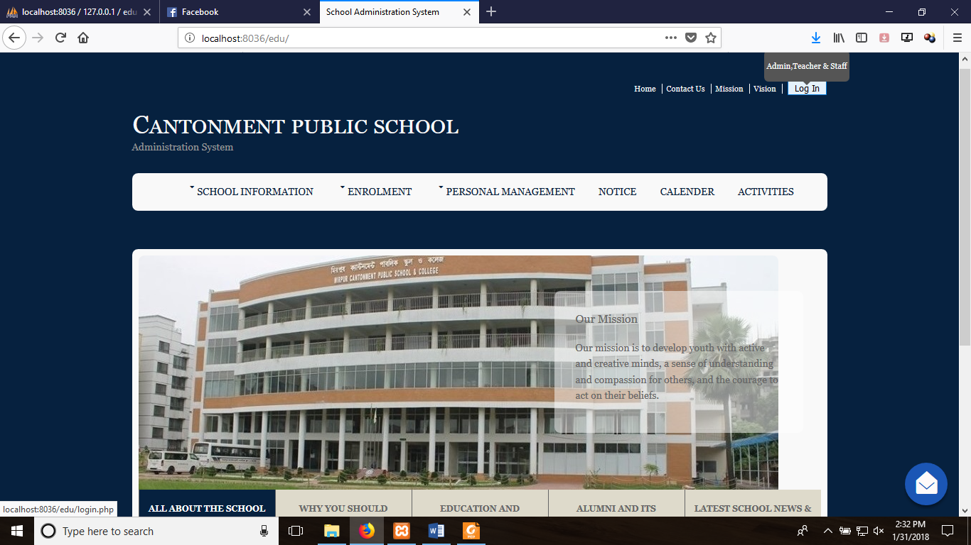

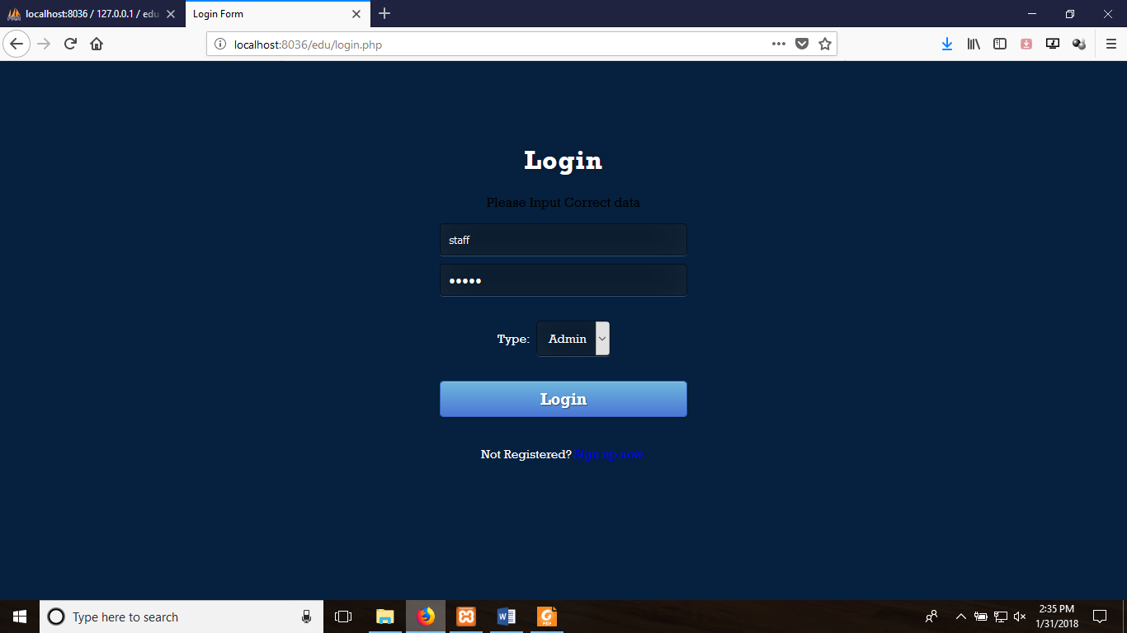**Login Page**

**Gallery**

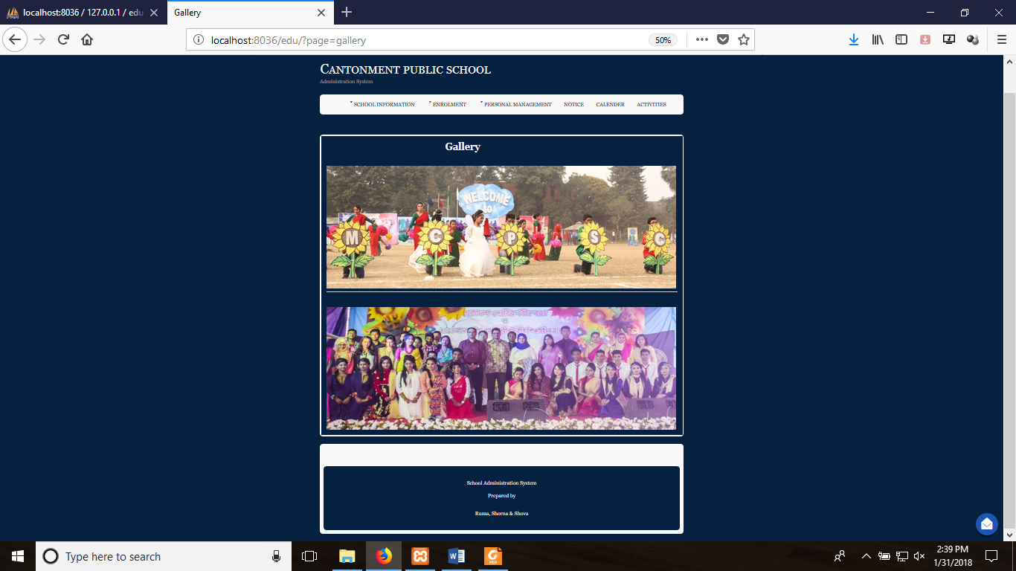

**SMS Online Admission Form**

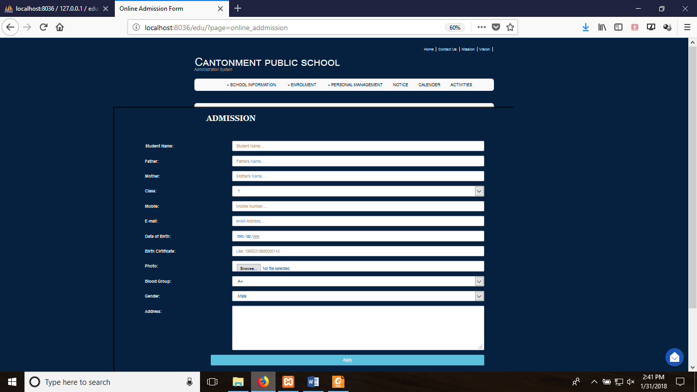

***Admin Page***

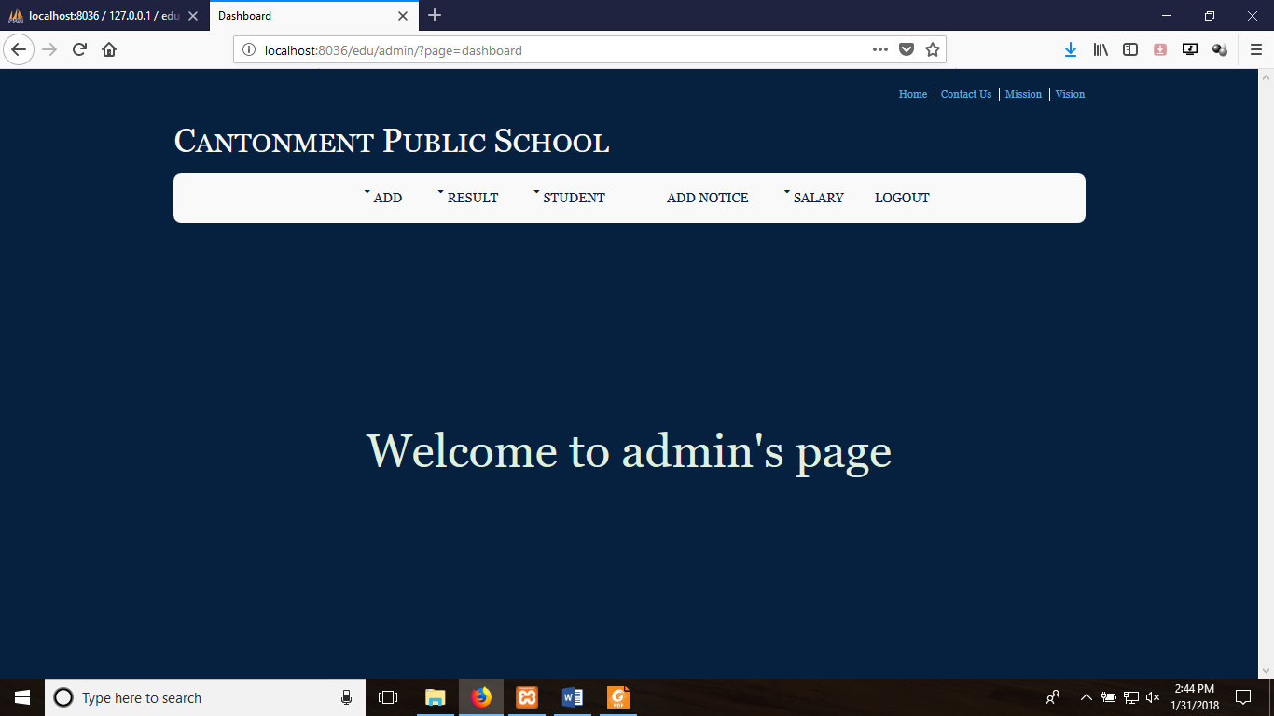

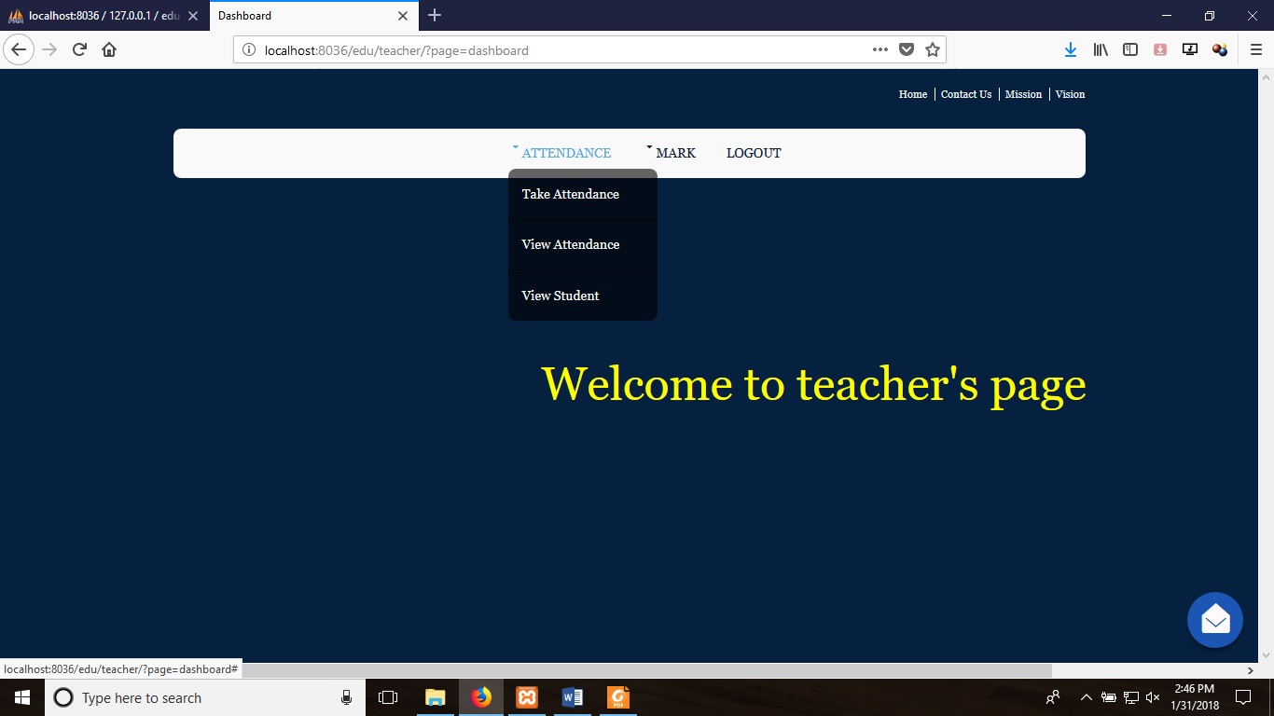***Teacher Page***

***Staff Page***

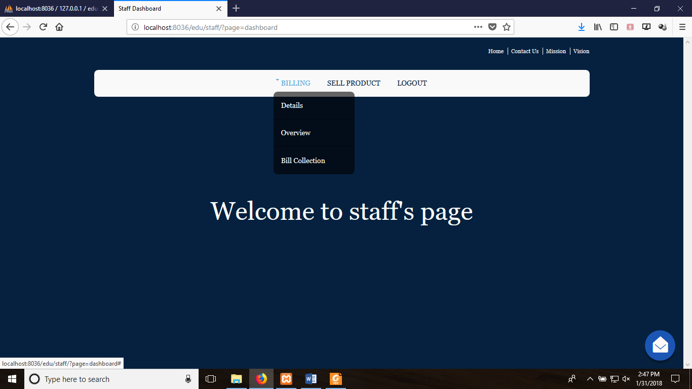

***Teacher’s Details***

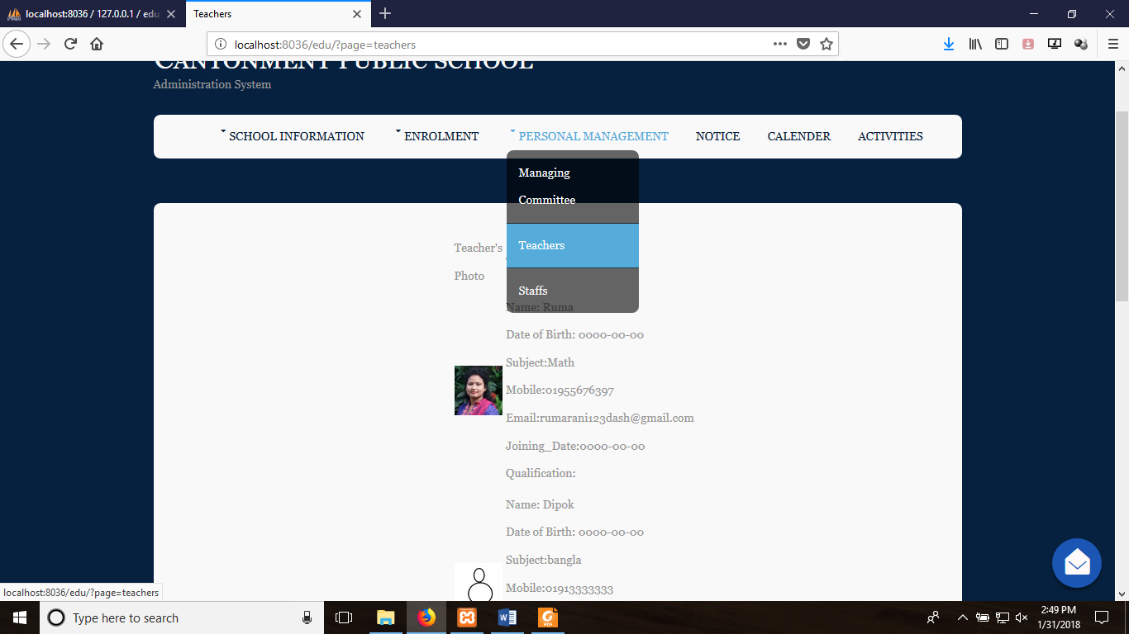

***Academic Calendar***

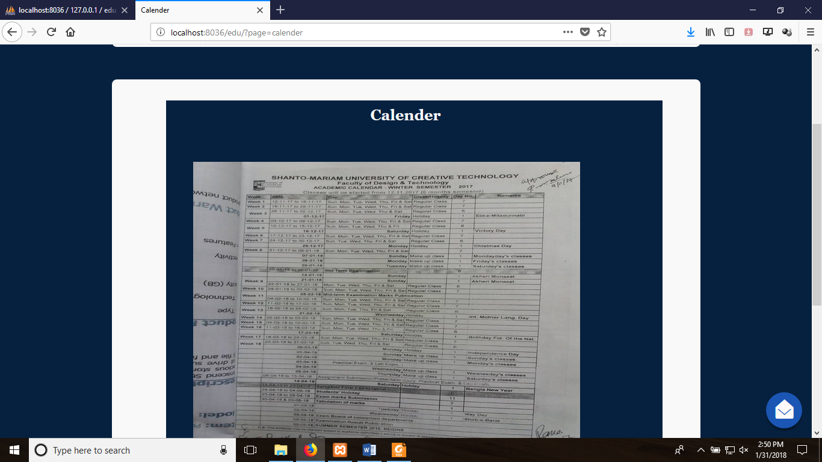

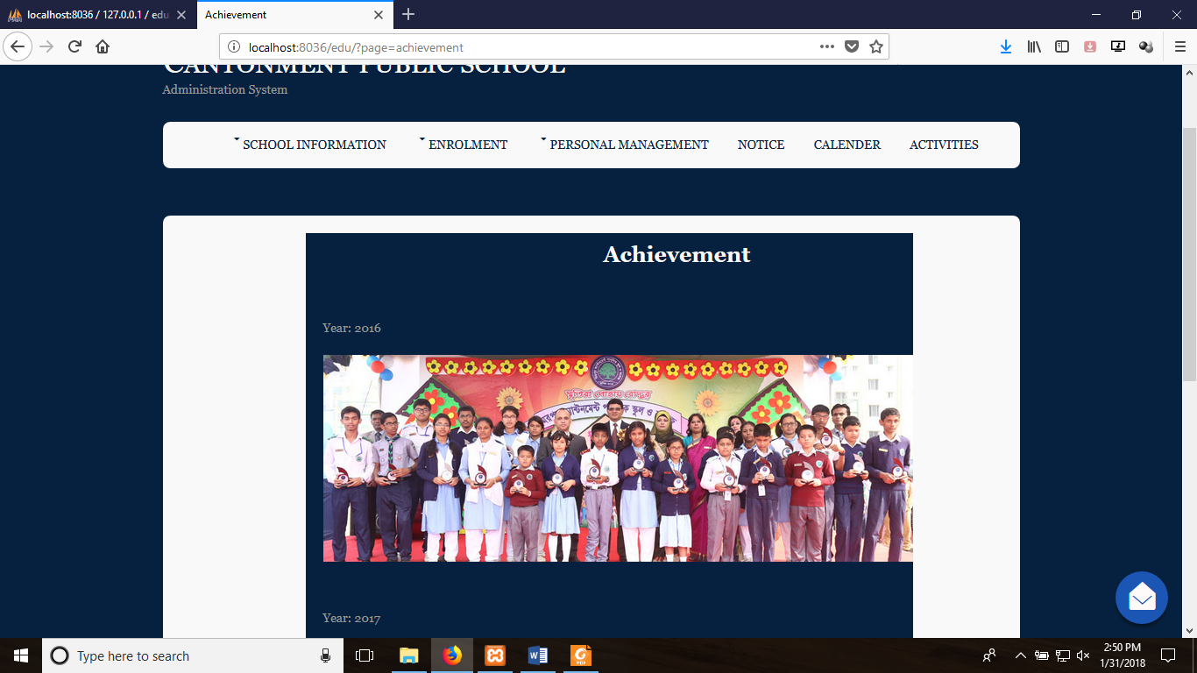***Achievement***